18.06.2019 YASS RESERVES REPORT
Although some Wednesday Walkers were somewhat apprehensive because of the very thick fog encountered on the way to Yass, the day turned out to be one of those brilliant sunny windless winter days that makes you glad to be outside. We first visited Yass Gorge which stretches from Flat Rock Crossing to the Yass Dam wall. We followed the Connors-Dawson Walking trail stopping many times to admire the river views, tall cliffs and rocky overhangs.
The reserve is undergoing restoration works and there are wonderful mostly native patches amongst the weedier areas. Callistemon sieberi lined the river, Eucalyptus camaldulensis arched over the water, Themeda australis waved its seed heads artistically along the cliff lines, Einadia nutans cascaded its red berries down rocks and pockets of yellow-backed bright blue Wahlenbergia luteola provided colour. Scattered stands of Dodonaea boroniifolia were of botanical interest especially when we found a deep crimson pod. The clutch of hatched lizard eggs was quite remarkable, as were the mossy and lichen covered boulders.
After lunch, we headed to Hattons Corner where flowering Westringia eremicola enticed us to the edges of a steep drop. Luckily no one fell off. Walking through remnant grassland we reached the river and admired the limestone cliffs and unusual geology. A great way to spend a winters day. Thanks Paul.
Kris Nash
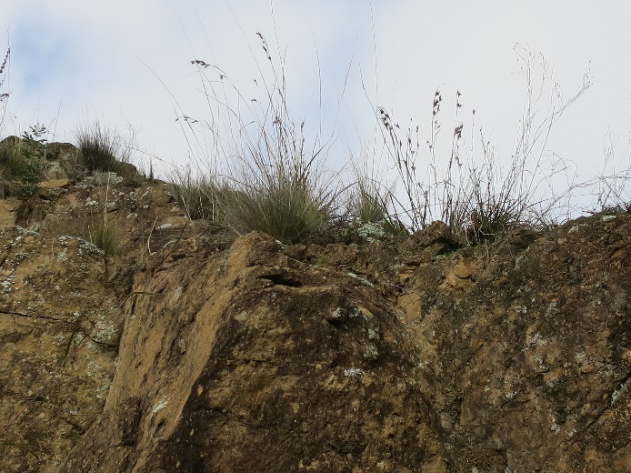 | 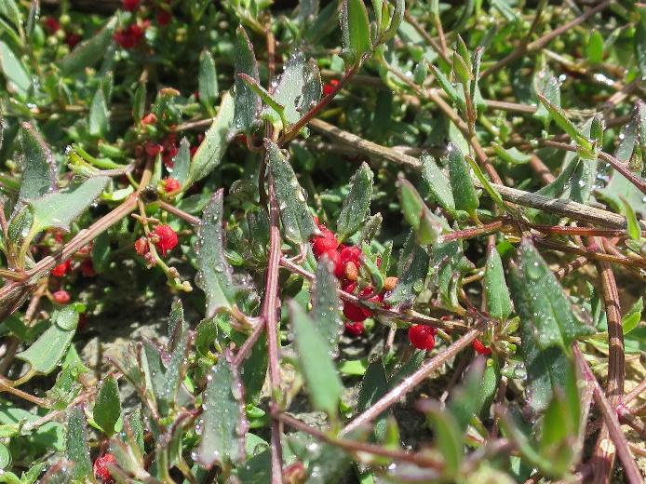
Themeda australis | Einadia nutans
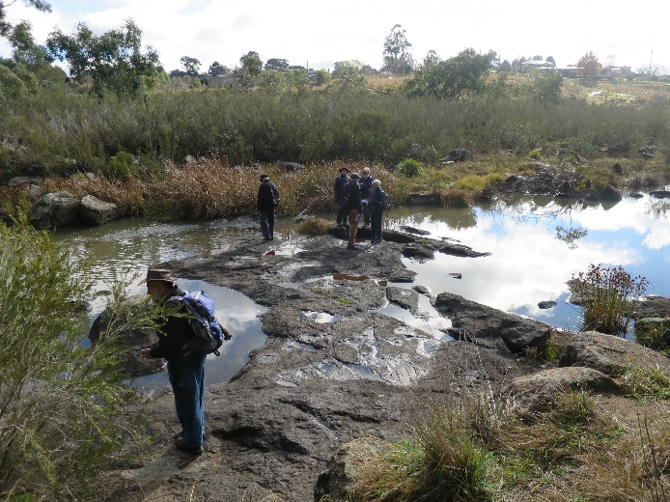 | 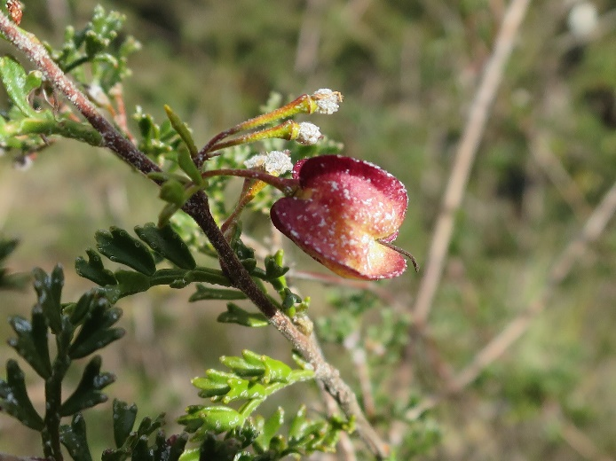
WW admiring ancient swimming holes and Callistemon sieberi on Yass River | Dodonaea boroniifolia
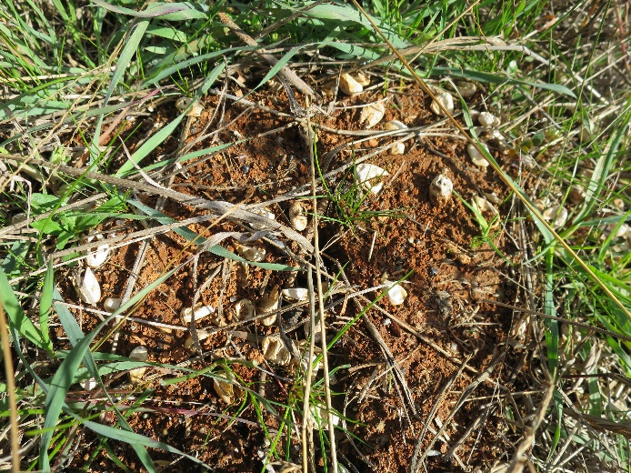 | 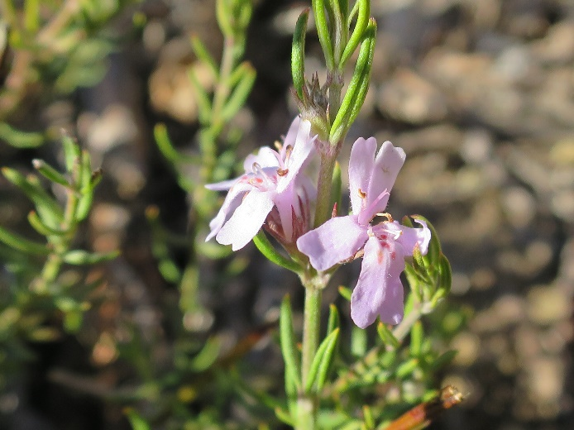
Hatchlings have left home | Westringia eremicola
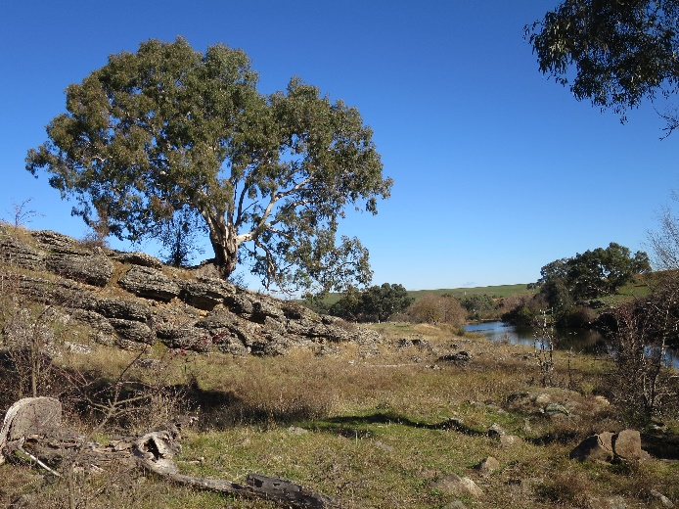 | 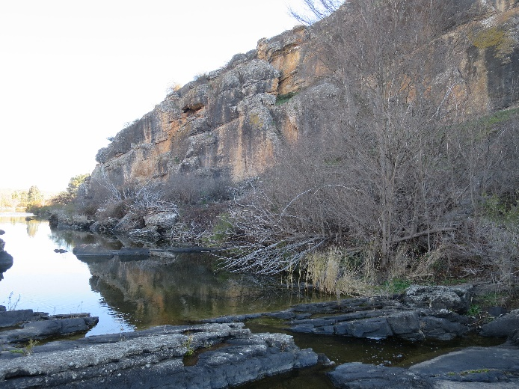
Eucalyptus camaldulensis | Cliff near Hattons Corner

