FOG member Andrew Zelnik originally trained and worked as an engineer, before switching to environmental science. Since his retirement in 2018, his involvement in environmental volunteering has expanded.
Long time ANPSC/FOG member, Margaret Ning, is renowned for her expertise in native grassy ecosystem sites, her eye for invasive weed species.
For July audience, their topic is the study and maintenance of the small but significant Top Hut Travelling Stock Reserve (TSR). It’s south of Canberra, halfway down the descriptively named Dry Plains Road, from Cooma to Adaminaby.
What are TSRs?

TSRs are (usually fenced) land parcels, reserved for travelling stock. The acronym can also refer to Travelling Stock Routes. In NSW, these kinds of rights and reserves go back to the 1860s.

Between the 1870s and 1930s, various sheep-disease and stock-protection laws led to the Pasture Protection Boards, also covering TSRs.

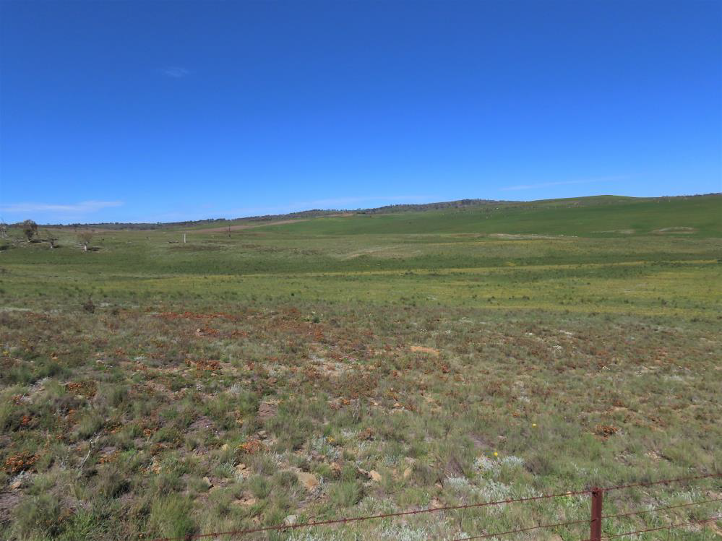
Top Hut, south paddock, spring 2020

By the 2000s, these had morphed into lands-protection then livestock-health authorities.

Unsurprisingly, a 2012 review found few TSRs still being used for moving stock to markets.

By 2020, numerous but not all NSW TSRs were under the control of Local Land Services (LLS) authorities. These were advised to transition to a “collaborative” funding model showcasing TSR investment opportunities.

FOG gets involved.

In the mid 1990s, local native-plant experts Rainer Rehwinkel and David Eddy chanced upon Top Hut, as a World Wildlife Fund/Dry Plains Landcare education site. David’s colourful 1997 photo graced the cover of the Grassland Flora field guide.

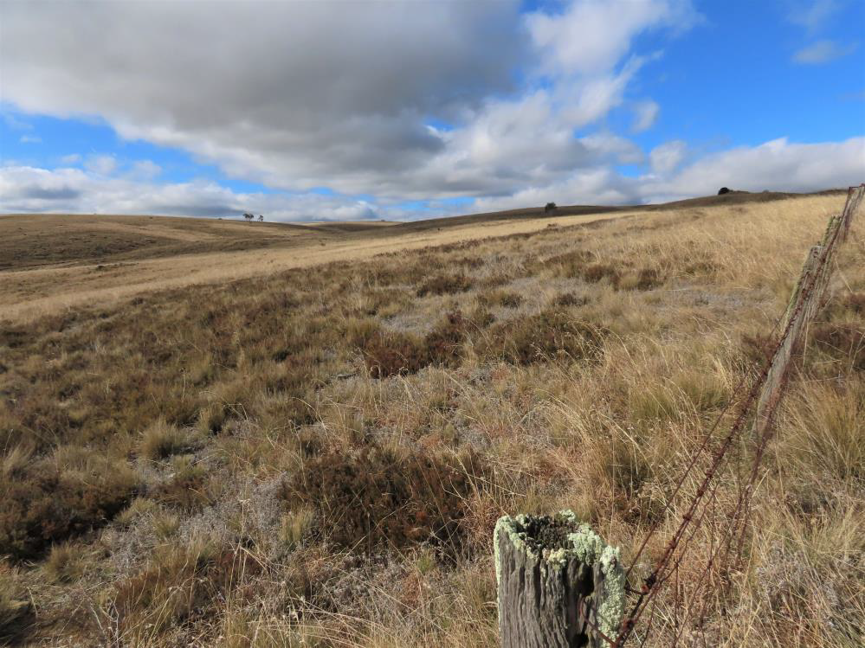
Top Hut, north paddock, winter 2022

FOG and ANPSC have been visiting Top Hut ever since. In Rainer’s recent opinion, this remnant “reserve is the most intact and floristically diverse grassland TSR in the south-eastern region”.

In mid 2020, the South East LLS granted FOG a five-year conservation lease over the reserve.

Top Hut today.

According to the cadastre, the present reserve is about 15 hectares only. The actual fenced area is three hectares smaller. There is a larger and flatter paddock on the southwest edge of the road, with a hillier and rockier paddock on the northeast.

The natural temperate grassland of Top Hut is rated as a Critically Endangered Ecological Community, hosting a remarkable range of flora and fauna for its size.

Native grasses include Themeda triandra (kangaroo grass), Dichelachne (plume grasses), and Poa spp.

The diverse and colourful flowers include many daisies and peas, also a couple that are endangered or vulnerable. Other native species include dagger wattle, woolly grevillea, pimelea, violet, veronica, geranium, carraway, ranunculus, trigger plant, vanilla lily, and sun orchid.

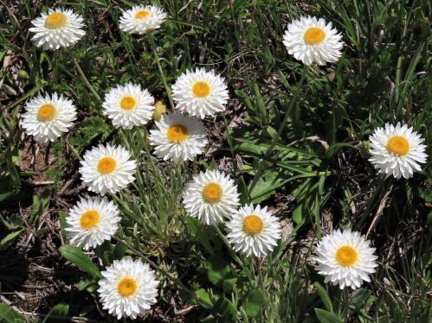
Endangered hoary sunray occurs at Top Hut
(continued)

Among the fauna are an endangered grassland earless dragon, a skink, a blue tongue, a snake, frogs, wolf spiders, and birds.

The dragons like a mosaic of tussock, with spaces in between. But they can’t dig their own refuge burrows. So they borrow these from spiders. Borrowed or shared burrows are quite common among mammals and reptiles worldwide.

Big management challenges.

From the beginning of the lease, FOG has faced labours of love.

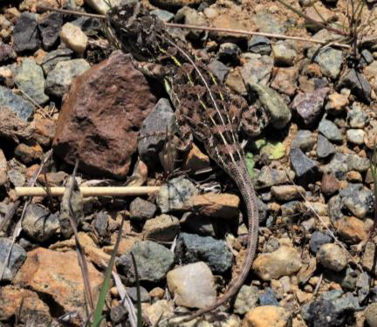
Endangered grassland earless dragon
occurs at Top Hut

Intensive La Niña rains have encouraged, if anything, too much biomass of native grasses, which is a problem for the dragons. The rains also encourage infestations of noxious weed species.

There was a big gap in the northside fence, inviting in sheep and goats. Southside, there were large and dangerous wombat holes, whose trampled areas invited weeds.

Weeding has been ongoing, including the wombat holes. Late 2021, the fence-gap was repaired. After due consideration of the biomass, FOG held a southside “slow cool” burn, in the winter of 2022.

Through 2022, FOG organised several volunteer (as well as paid) “spray days” to control the weeds. Volunteer spraying continued thereafter.

By early 2023, the vegetation had bounced right back, from the burn. In April, the south paddock was grazed for 12 days, to manage biomass. The sheep rejected certain Poa species but revealed further wombat diggings.

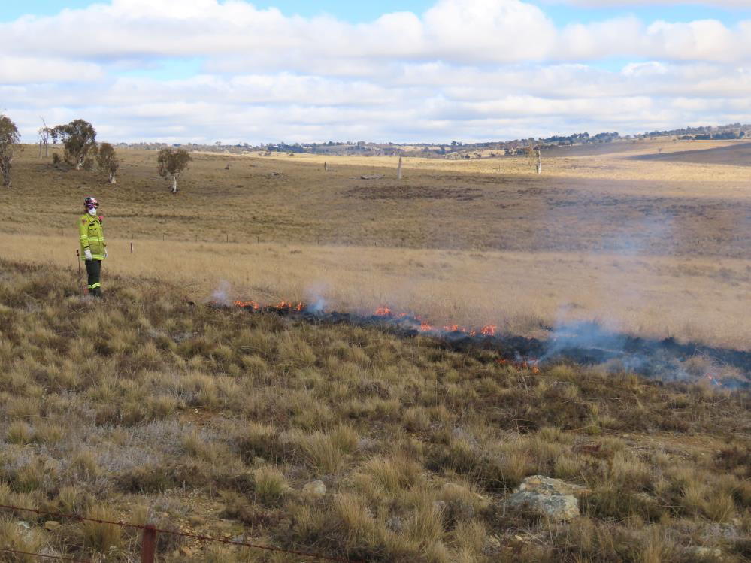
South paddock, “slow cool” burn, winter 2022

What comes next?

Biomass reduction is a possibility for the northside as well – whether via fire or sheep/cattle grazing.

In the spring of 2023, FOG will get back into the south paddock to keep the weeds down. Further biomass reduction is a possibility – perhaps via cattle grazing this time.

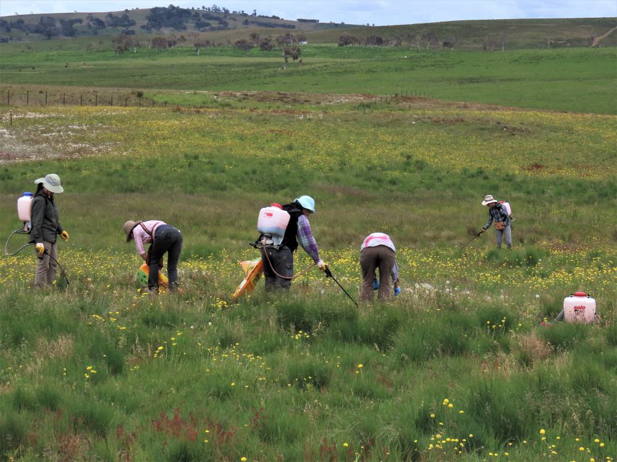
South paddock, weed spray, spring 2022

This being Australia, a hot, dry “El Niño Alert” is current in 2023. Were that to materialise, FOG can expect different management challenges, down at Top Hut.

Stephen Saunders, ANPSC President

