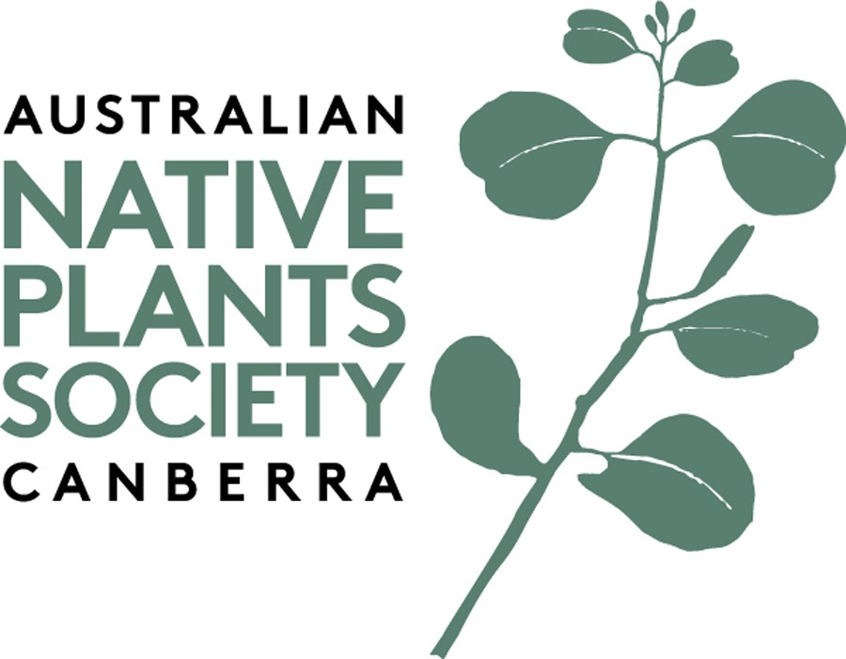
Australian Native Plants Society Canberra
DAGs & GDSG Attendance Register

Location .................................................................... Date ……………………………...................…………

Hosts .................................................................... Time ……......................................................
Attendance Register Terms and Conditions
Please read the information below and sign that you agree to these caveats, so we have a record for liability & insurance cover.
- I am participating in this Daily Activity Group (DAGs) and Garden Design Study Group (GDSG) as a volunteer in all respects and I am aware that participation may expose me to risks that could lead to injury, illness or death or to loss of or damage to my property.
- I will notify the leader if I become ill or have an accident or suffer injury.
COVID-19
- I agree to abide by ANPSC Guidelines regarding COVID 19 restrictions to reduce the likelihood of the spread of infection.
- I have adequate personal first aid and hand cleaning supplies.
- I understand I am not covered by ANPSC insurance for COVID-19 and agree that I will take personal responsibility for my safety in respect of COVID-19.
Note: Visitors (ie non-ANPSC members) are not covered by ANPS insurance and participate at their own risk.
 | Member’s Name  Visitors: please add address | Phone  number | Email | Car  Rego | Reply email  sent | Signature | Emergency contact  phone no.
1
2
4
5
6
7
8
9
10
11
12
13
14
15
16
17
18
19
20
21
22
23
24
25
26
27
28
29
30
31
32

DAGs Coordinators)
dagsleader@nativeplantscbr.com.au
0407268797

Version: 2021-05-31

