Wednesday Walk, 5 June 2019 - Dhurrawarri Buranya Walk_Googong South

Wednesday Walkers enjoyed the wonderful weather at Googong. We did start the day in very windy conditions until we got further down the slope and into the lee side of the hill.

The vegetation showed quite clearly the effect of the drought, only the hardiest of understory plants are surviving. Lots of dead branches on the ground.

A lack of water has caused soil cracking and encouraged weed growth along the shores of both Burra Creek and Queanbeyan River. The population of Dillwynia glaucula (listed as endangered in NSW) is not looking very healthy although there is some regeneration visible. Otherwise, the eucalypts were spectacular, as always.

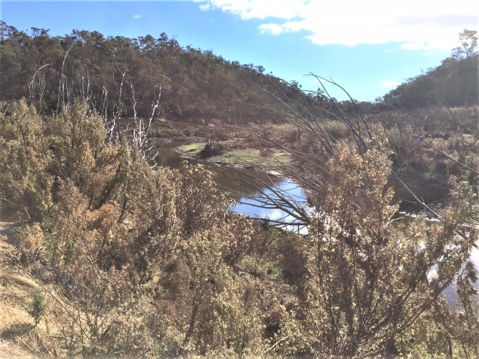 | 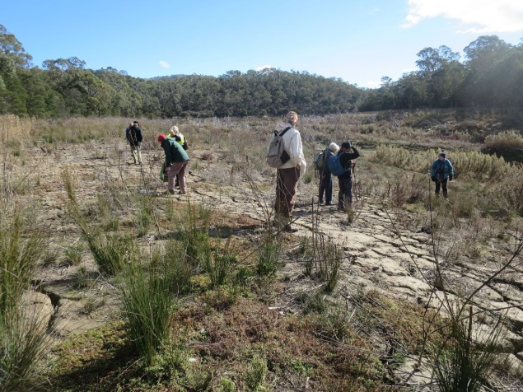
Burra Creek | Cracked shores Burra Creek
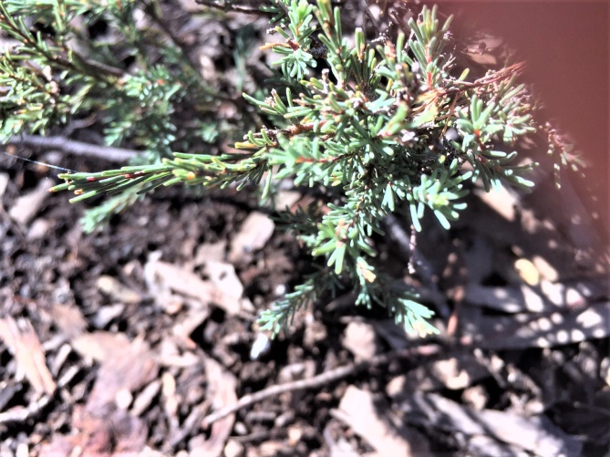 | 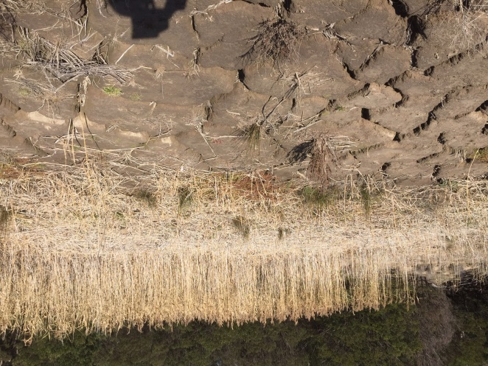
Dillwynia glaucula | Parched creek bed

